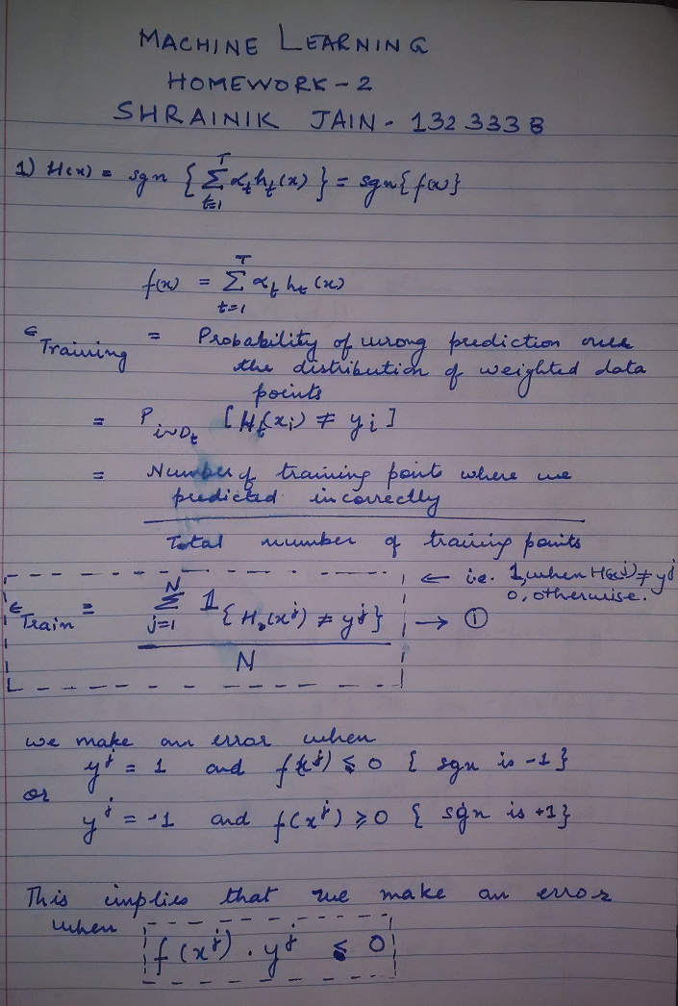

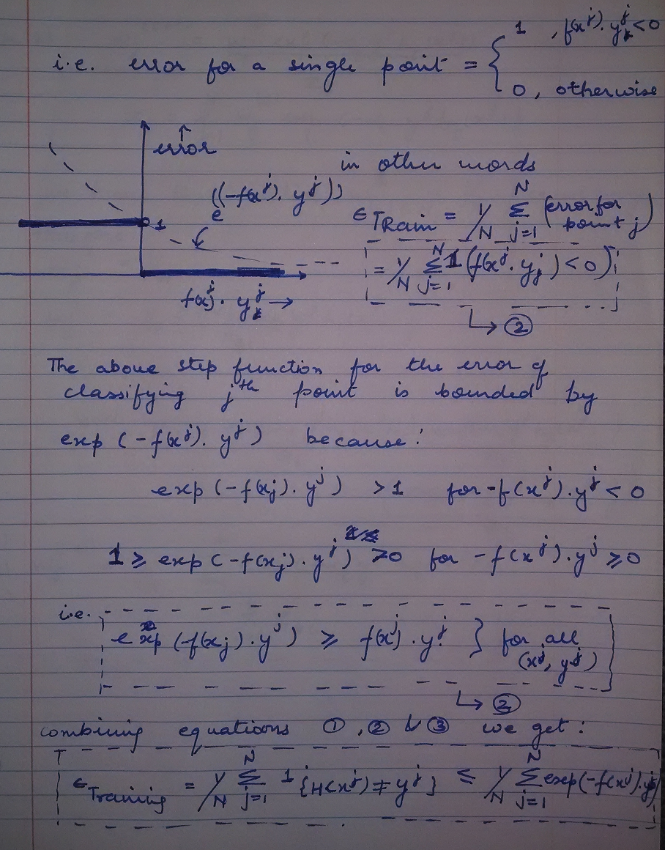

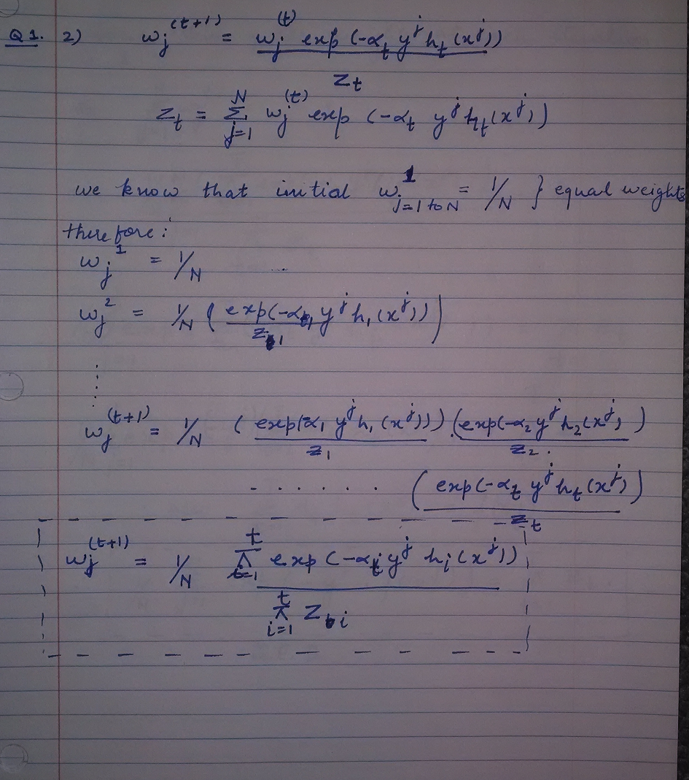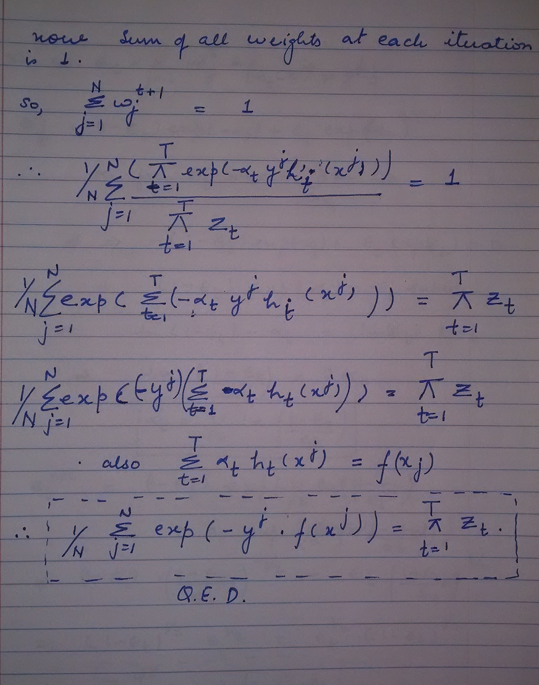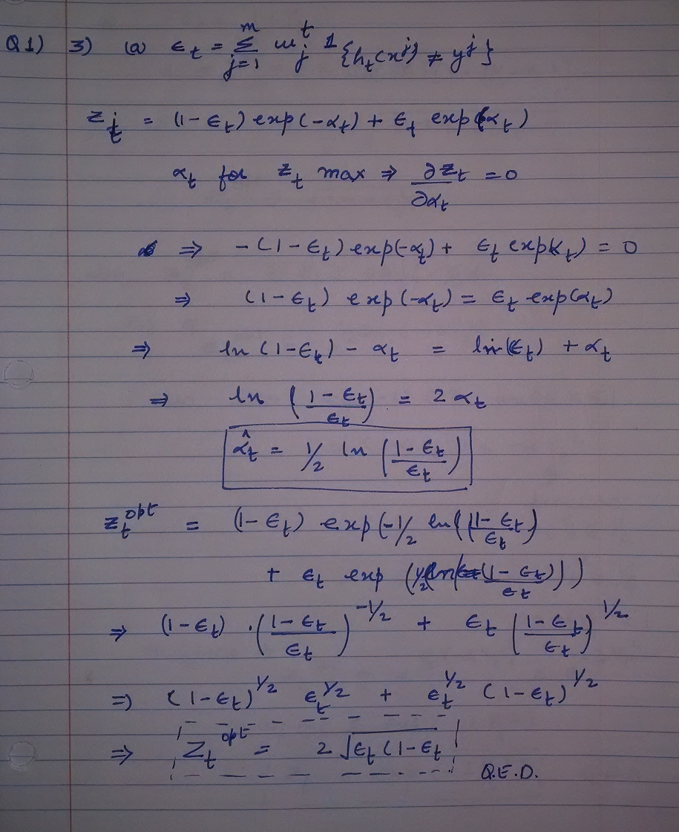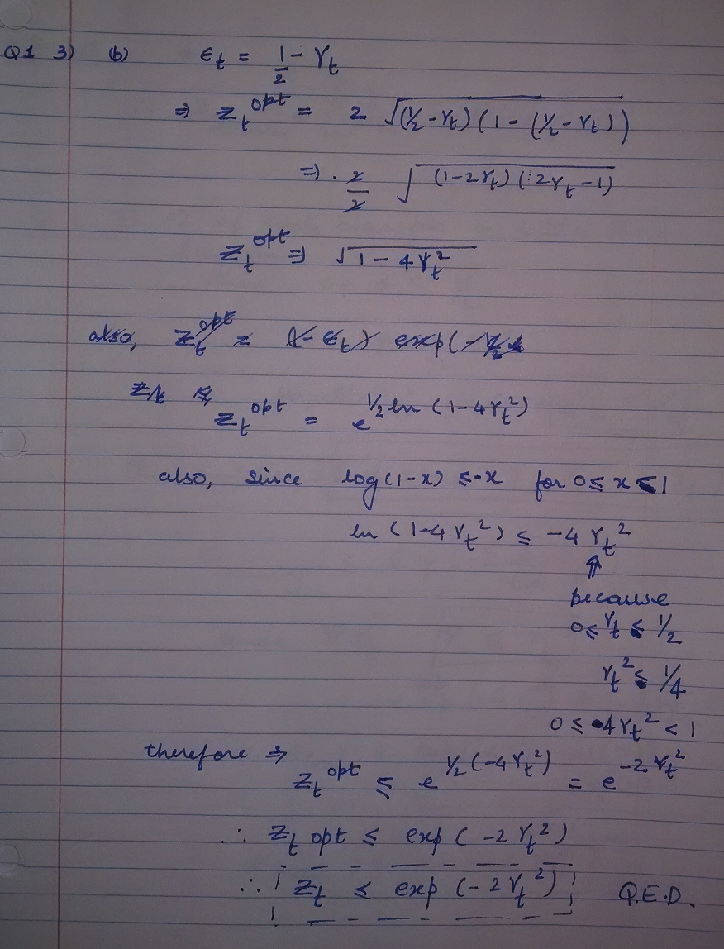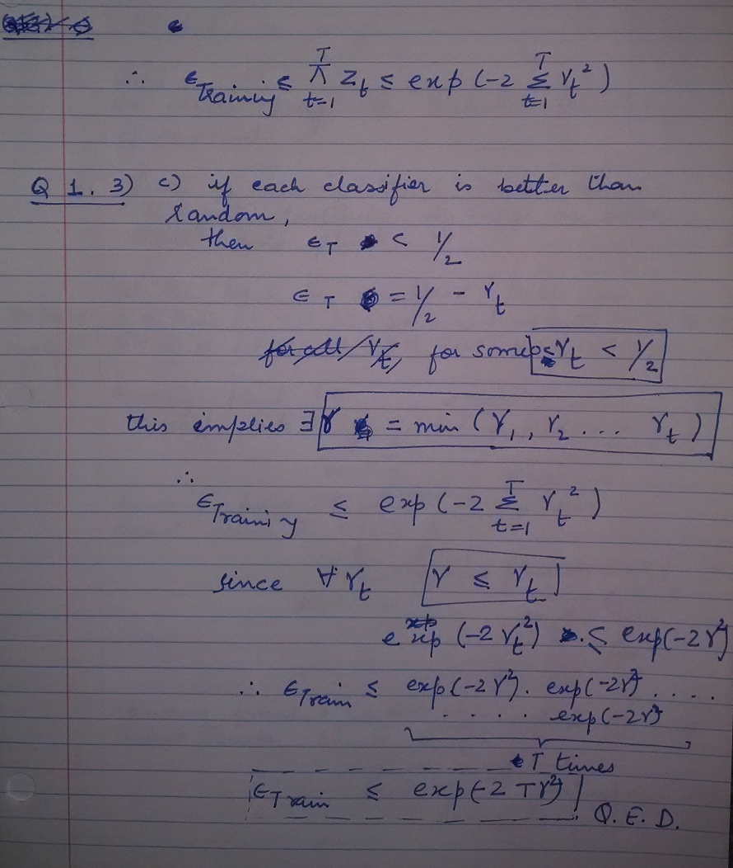

**Ques 2. 1**

The following figure is the Voronoi diagram for the dataset. The Redline is the decision boundary, i.e. all points left of it are positive. 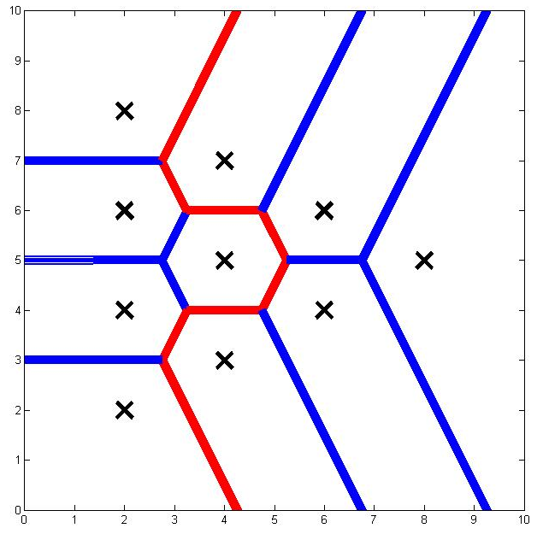

**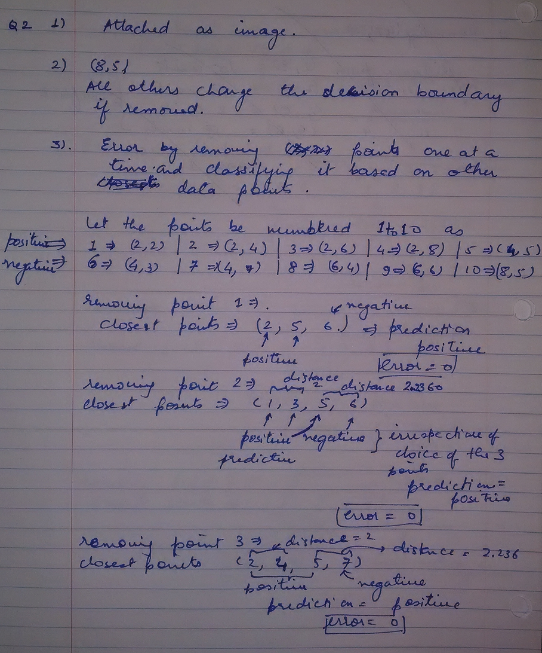  
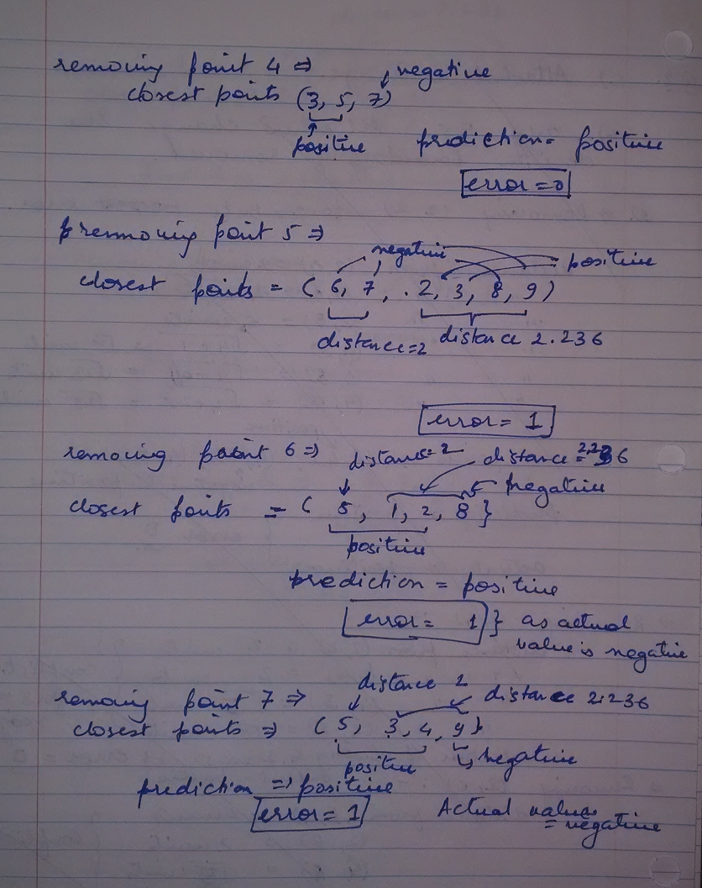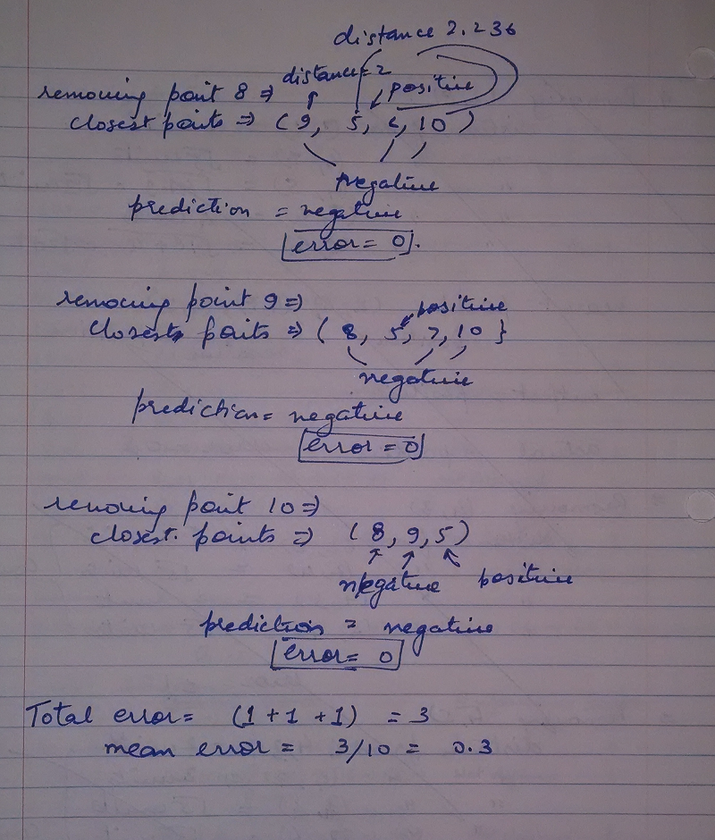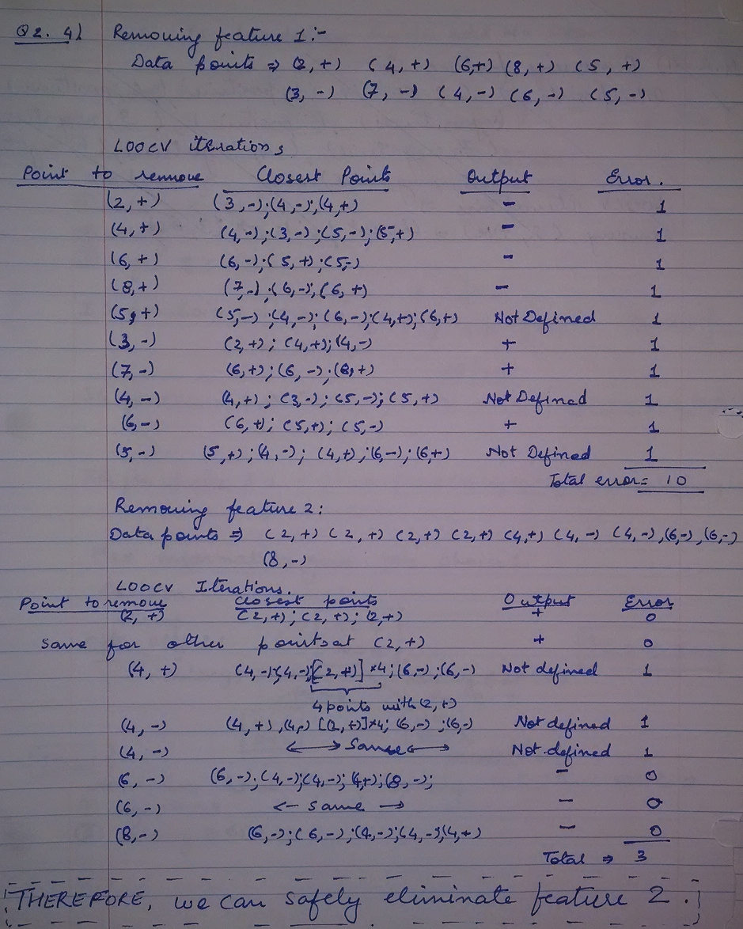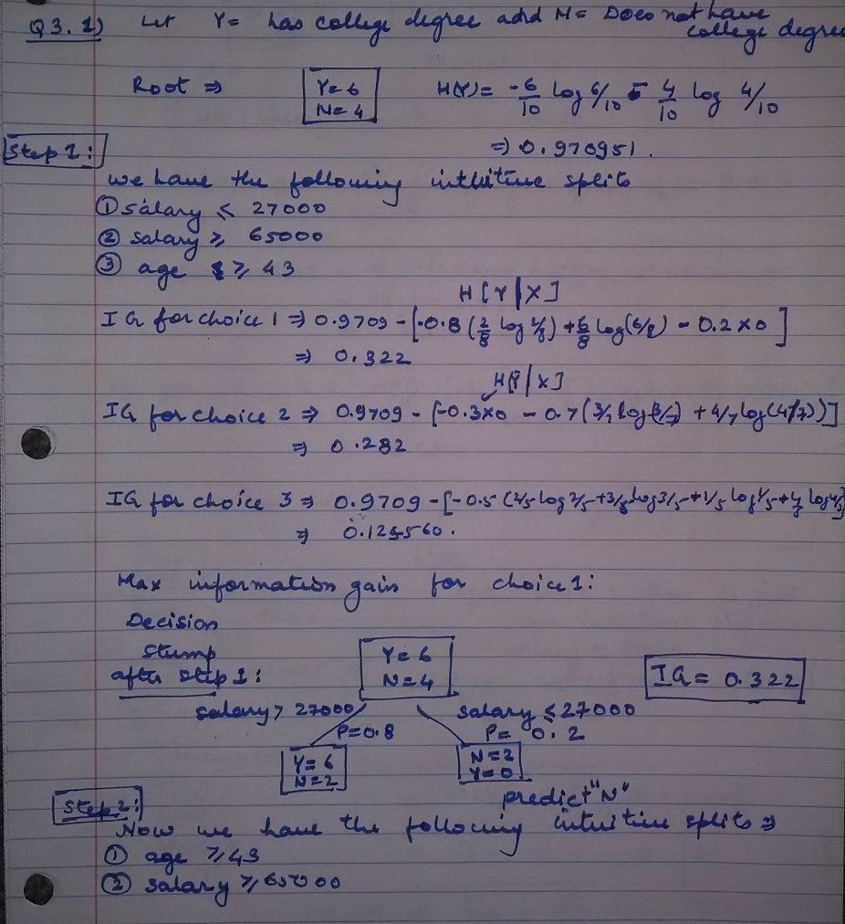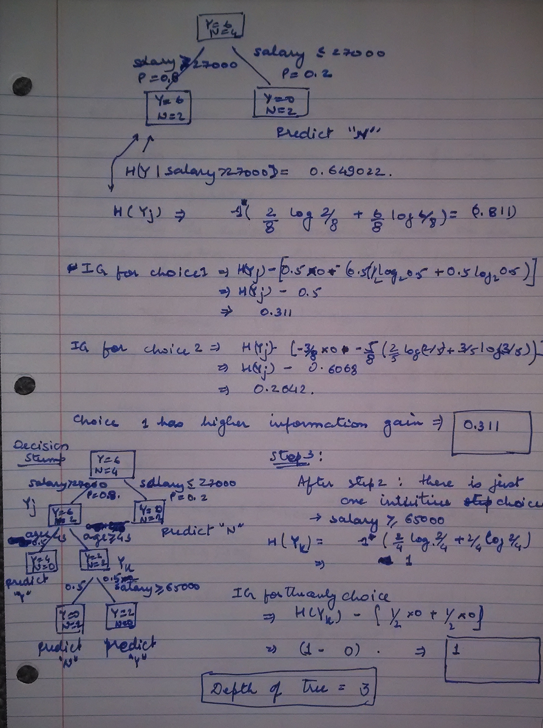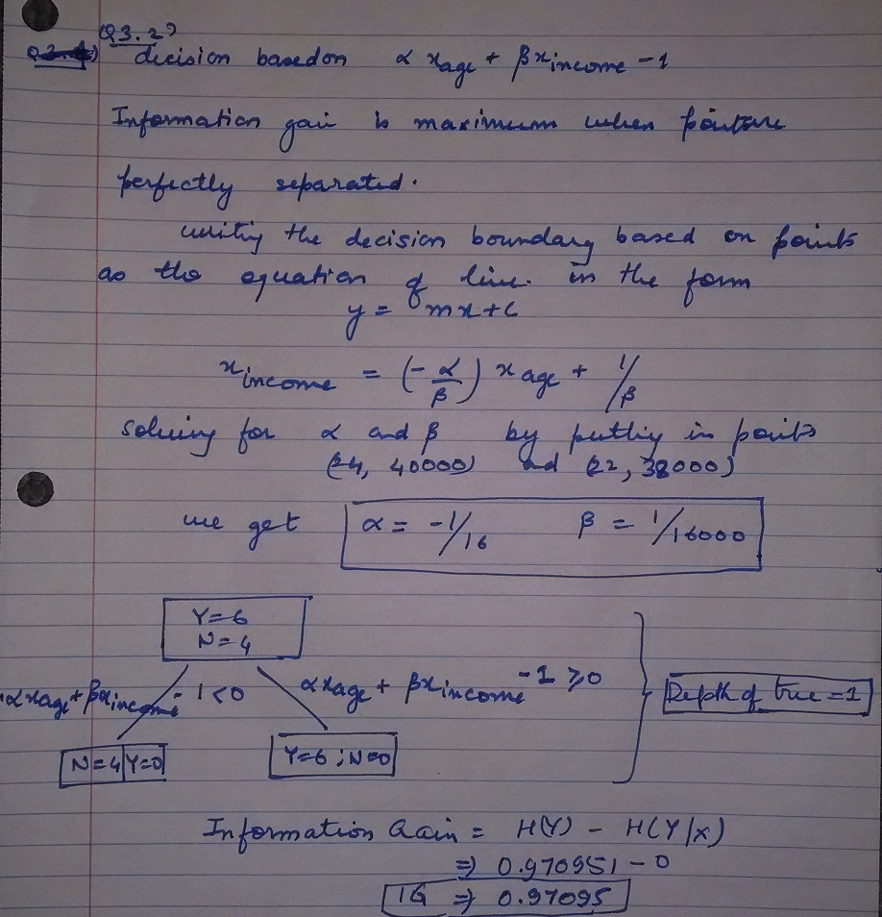Ques 3.3**   
Advantages of multivariate decision trees:

* More than one feature can be tested for per decision, this helps getting a way better predictor when the data points are linearly separable.
* Training error is lower as more complex models are allowed (decision based on multiple variables and rather than a single variable).
* Multivariate decision trees will have, on an average, smaller tree size.

Disadvantages of multivariate decision trees:

* The computation cost (CPU Time) of the learning algorithm is very high (imagine running linear regression again and again for each decision node), as a lot of features need to be tested to find out the maximum information gain per step. While the univariate algorithm requires considering only one feature at a time.
* On smaller datasets, multivariate trees tend to over-fit a lot because of standard deviation in the data points. This leads to higher test errors. Multivariate trees require a lot of data-points which might or might not be present.

**Ques 4.4.1**

Actual weight update step:

$$w_{i}^{t+1}= w_{i}^{t}+ η\left\{-λw_{i}^{t}+\frac{1}{N}\left(\sum_{j=1}^{N}{x_{i}^{j}\left[y^{j }- \frac{e^{w_{0}+ \sum{w_{i}x_{i}^{j}}}}{1- e^{w_{0}+ \sum{w_{i}x_{i}^{j}}}}\right]}\right)\right\}$$

Weight update step as in python (Y is Nx1, X is Nx(D+1), W is (D+1)x1):

yj_minus_p = Y – (exp(X.dot(W))/(1+ exp(X.dot(W))))

W[0] = W[0] + (eta / N) * sum(yj_minus_p)

W[1:] = (1 - eta * lmbd) * W[1:] + eta * (array(yj_minus_p).dot(X[:,1:]) / N)

**Ques 4.4.2**

**a)**

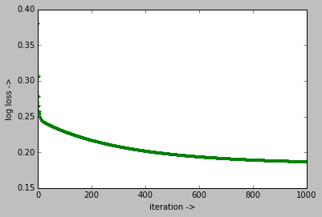

**b)** SSE for batch gradient descent with 1000 iterations: 54.0

**Ques 4.4.3 a)** Number of iterations with the stopping criteria: 13

**b)**

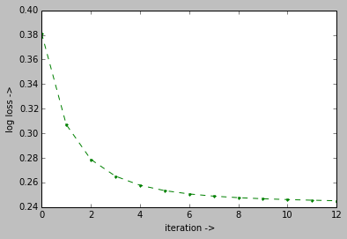

**c)** SSE for batch gradient descent with the stop criteria: 54.0

**Ques 4.5.1**

Actual weight update step:

$$w_{i}^{t+1}= w_{i}^{t}+ η\left\{-λw_{i}^{t}+x_{i}^{j}\left[y^{j }- \frac{e^{w_{0}+ \sum{w_{i}x_{i}^{j}}}}{1- e^{w_{0}+ \sum{w_{i}x_{i}^{j}}}}\right]\right\}$$

Weight update step as in python (Y is Nx1, X is Nx(D+1), W is (D+1)x1):

yj_minus_p = Y[j] - (1-1/(1+exp(X[j,:].dot(W))))

W[0] = W[0] + (eta) * yj_minus_p

W[1:] = (1 - eta * lmbd) * W[1:] + eta * (yj_minus_p * (X[j,1:]))

**Ques 4.5.2**

**a)** L2 Norm for lambda = 0 is: 1.92503456434

L2 Norm for lambda = 0.3 is: 0.283520413611

**b)** SSE for lambda = 0.3 is: 54.0

**c)** Feature Weights for INTERCEPT: -3.10616785425

DEPTH: 0.109353101677

POSITION: -0.006094751226

**Ques 4.5.3**

After 5 iterations, log loss with:

Stochastic Descent: 0.197392978738

Gradient Descent: 0.257743788383

Stochastic Descent seems to converge faster.

**Ques 4.6.1**

For predictions made by SGD running with one pass over data and lambda = 0.3 and eta = 0.1:   
Precision and Recall for class 0: 0.946, 1.0

Precision and Recall for class 1: 0, 0.0

**Ques 4.6.2**

For predictions made by batch gradient descent running for 10000 iterations over the oversampled data and with lambda = 0.3 and eta = 0.01:

Precision and Recall for class 0: 0.94140625 0.509513742072

Precision and Recall for class 1: 0.049180327 0.444444444444 ­